LEETCODE ARRAY SOLUTIONS

1)Find the Duplicate number

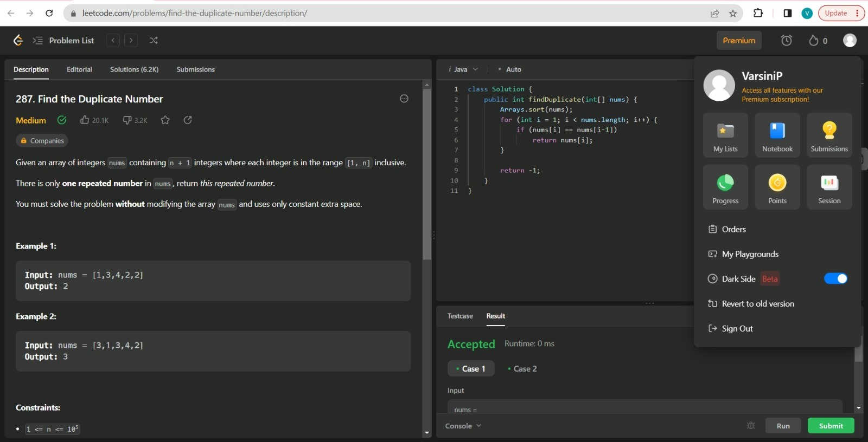

2)Number of Good Pairs

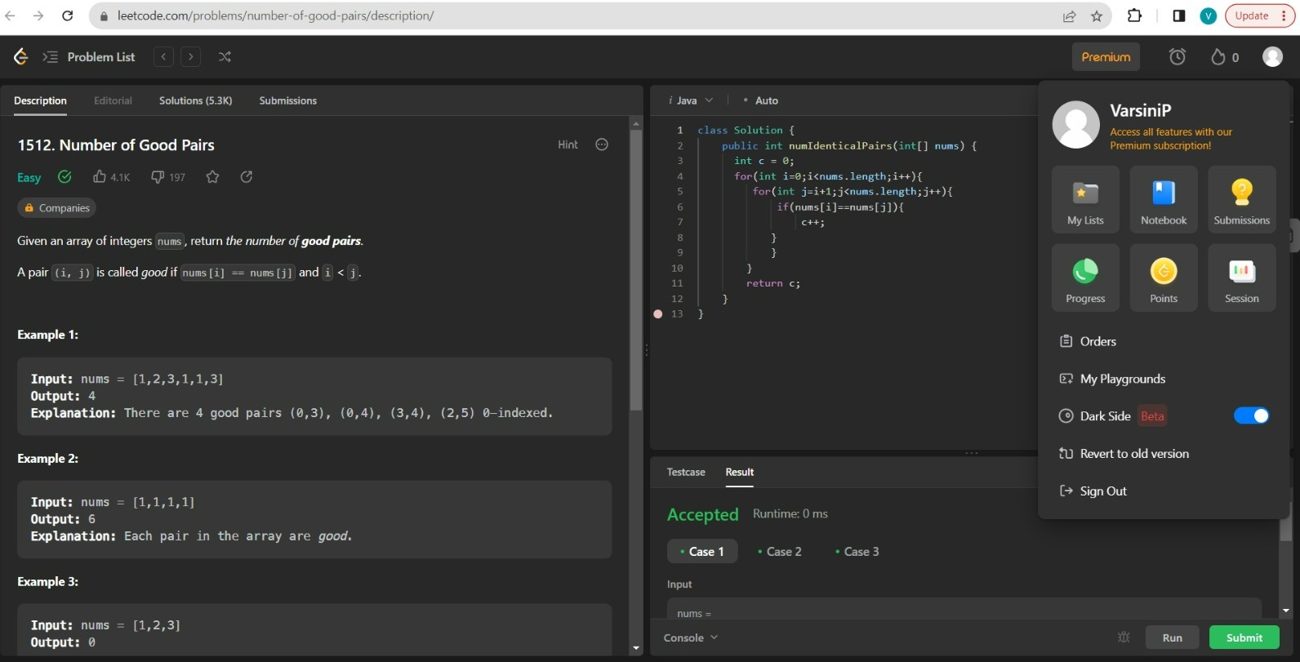

3)Find Greatest Common Divisor of Array

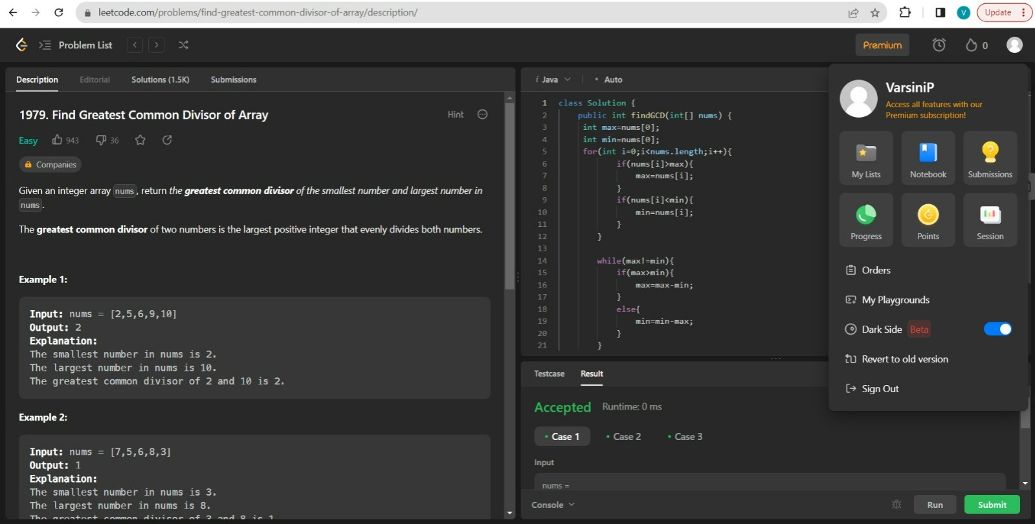

4)Unique Number of Occurrences

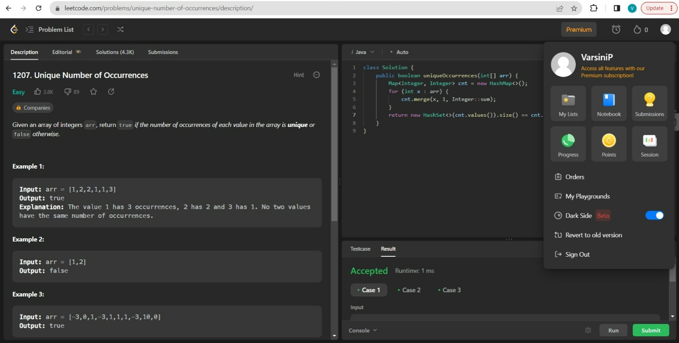

5)Find all Duplicates in an Array

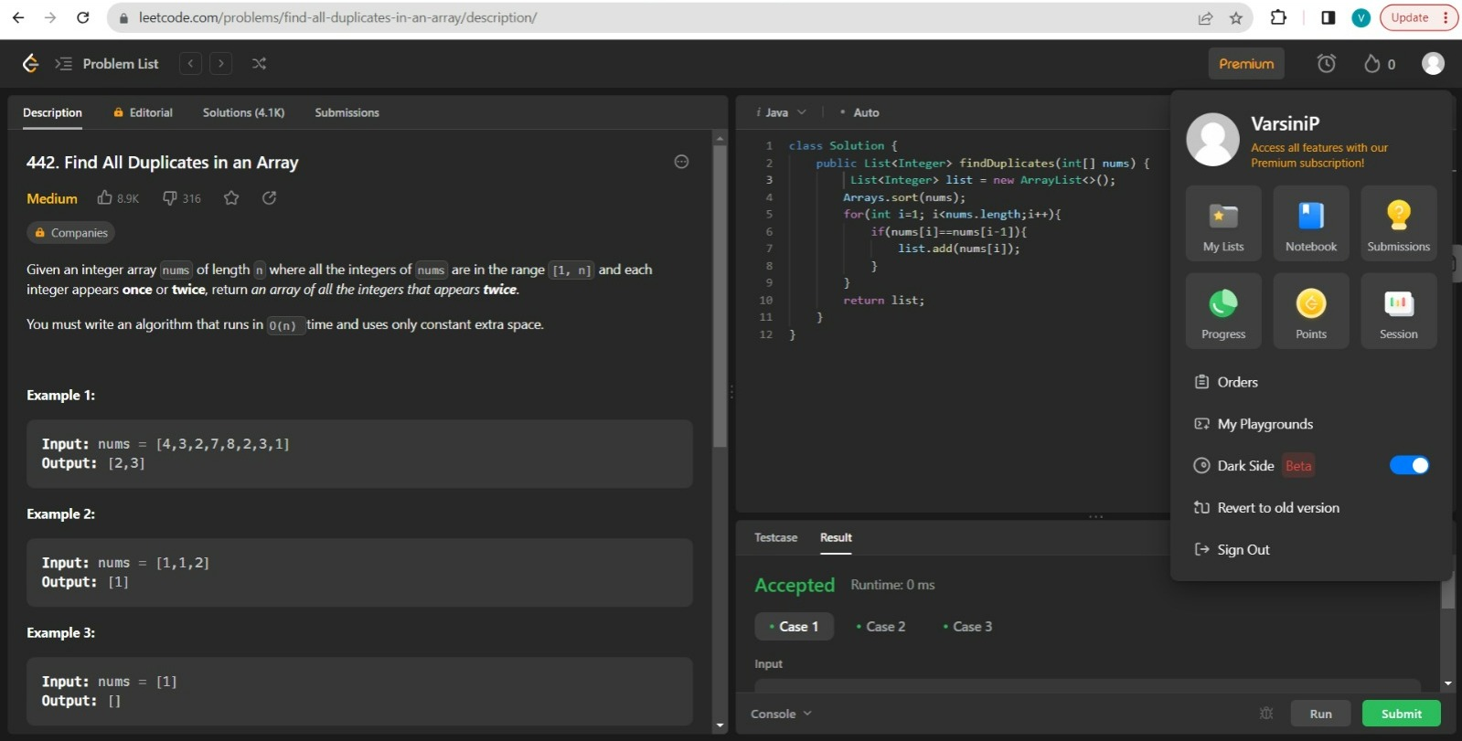

6)Maximum Points you can obtain from Cards

